Get To Know Your Stock: Carnival Corp. (June 2018)

Carnival Cruise Lines was launched in 1972, setting sail in a second-hand ship that ran aground and had just enough fuel to make a one-way trip from Miami to San Juan, Puerto Rico. Founder Ted Arison, an Israeli businessman and the son of a ship owner, was no stranger to the high seas. He owned and operated a fleet of cargo ships before co-founding the Norwegian Cruise Line in the mid 1960s.

Arison originally funded Carnival Cruise Lines with $1 million in assets he seized from Norwegian (then known as Norwegian Caribbean Lines) during a litigious split with his business partner. Arison changed the face of the cruise industry, introducing a broader demographic to floating vacations on Carnival’s affordable, casual “fun ships.”

Since its maiden voyage, Carnival Corp. (traded on the New York and London stock exchanges under the symbol “CCL”) has morphed into the world’s largest leisure travel company. It sails to over 700 destinations and operates more than 100 ships under nine cruise brands. Carnival Cruise Lines is the company’s largest. Its other brands include Princess Cruises, Holland American Line, Costa Cruises and Cunard, known for its luxury transatlantic crossings.

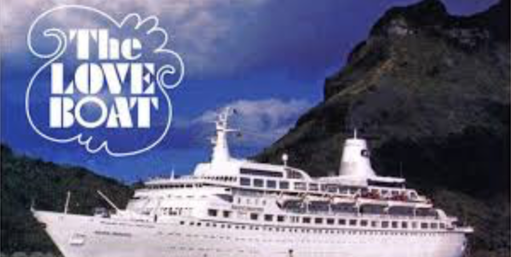
Carnival Corp.’s 120,000 employees serve more than 11.5 million passengers each year. According to industry data, the company holds nearly half the market share of the global cruise industry —nearly double that of its largest competitor. Carnival Corp. has also developed several television shows for major networks. The company’s ships have gained widespread recognition, even among armchair travelers. The original Pacific Princess, once part of Carnival’s Princess fleet, sailed into American homes from 1977 to 1987 on the television show “The Love Boat” and even made some trips during filming sessions. Actors Jack Lemon, Walter Matthau, Jon Voight, Sandra Bullock, Ryan Reynolds and Lindsay Lohan appeared in movies set on cruise ships that belonged to the Carnival Corp. family.

The company also takes sustainability seriously, noting that on its seven-day cruises 9,300 pounds of recyclables are collected and processed.

Carnival Cruise Line continues to launch new ships and will soon enter the Australian market. In 2019, it’ll introduce a 24-day cruise from California to Singapore (the longest cruise in the company’s history), a round-trip cruise from California to Hawaii and a Panama Canal Cruise. Carnival Corp. is buying port, railway and retail operations in Alaska. In 2016, it became the first cruise company in over 40 years to bring passengers directly from the U.S. to Cuba.

Carnival Corp. is also thinking about potential opportunities in Asia. “China someday is going to be the largest cruise market in the world,” said Carnival Corp. CEO Arnold Donald in a recent interview with TheStreet. “There’s no question about that and the question is what role are we going to play and how are we going to participate.”

