Get To Know Your Stock: AMC Networks

Whether or not you’ve binge watched seasons of such television shows as “Mad Men,” “The Walking Dead,” “Breaking Bad” or “Better Call Saul,” you may want to tune into AMC Networks Inc. (Nasdaq: AMCX).

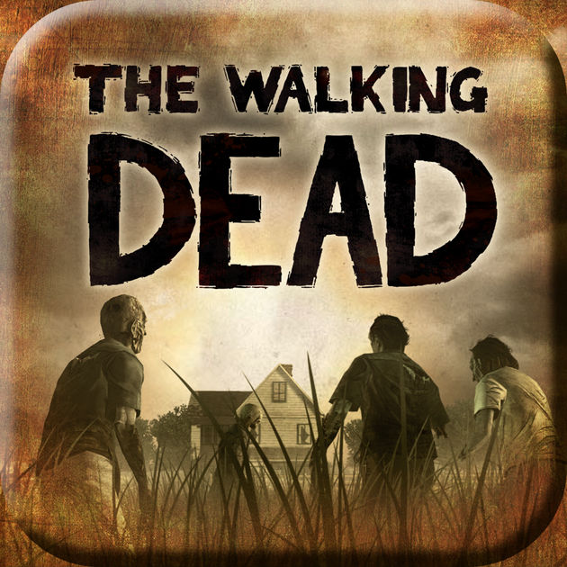
The New York City-based entertainment company, a leader in cable television, has been producing programming and movie content for more than 30 years. Prior to its 2011 spin-off from Cablevision Systems Corp., AMC Networks was known as Rainbow Media Holdings.

AMC Networks owns and operates five nationally distributed programming networks including AMC, IFC, WE tv, SundanceTV and, through a joint venture with BBC International, BBC America. It also owns and operates AMC Studios, its television production business; IFC Films, a leading U.S. distributor of independent films; and an international programming business.

AMC Networks delivers programing that reaches subscribers in more than 140 countries and territories throughout North America, South America, Europe, the Middle East and parts of Asia and Africa. The company ramped up its global business through its $1 billion acquisition in 2013 of Liberty Media’s Chellomedia. AMC Networks also makes content available through such third-party digital platforms as Netflix, Hulu, Amazon Prime, iTunes and YouTube TV.

AMC Networks makes more money through distribution (what it charges cable companies to carry its channels) than through advertising. In mid-2017, it teamed up with Comcast to offer a $4.99-a-month upgrade option called AMC Premiere that lets viewers watch the latest episodes of AMC shows without commercial interruptions. This year, AMC Networks and Charter Communications announced a partnership to develop and co-produce original programming for Charter’s Spectrum platform.
AMC Networks president and CEO Josh Sapan pioneered the strategy of same-day theatrical and video-on-demand release—a model widely used today throughout the movie industry. (Unusual fact: he also has the world’s largest collection of antique lightning rods, totally more than 100.)

AMC was the first basic cable network ever to win an Emmy Award for Outstanding Drama Series, in 2008, for “Mad Men.” The original series won the award four years in a row and “Breaking Bad” subsequently scored the award twice. According to AMC Networks, “The Walking Dead” is the highest-rated series in cable history and, for the last five years, the number one show on TV among adults ages 18-49.
AMC’s IFC Film successes include the movies “Boyhood” (which won an Oscar and was nominated for five) and “My Big Fat Greek Wedding” (an Oscar nominee).

