Get To Know Your Stock: Qualcomm

Qualcomm Inc. (Nasdaq: QCOM) may not be a household name for most consumers, but the telecommunication leader’s computer chips and advanced wireless technologies likely play an integral role in their smartphones, laptops, cameras, cars, medical devices and other products. According to the company website, “billions, maybe trillions of times a day” people around the world touch something “made better” by Qualcomm.
No matter how many zeros this actually is, the networking equipment maker continues to drive innovation. It has been assigned thousands of patents—2,897 in 2016 alone—and licenses companies to design, manufacture and sell products based on its technology.
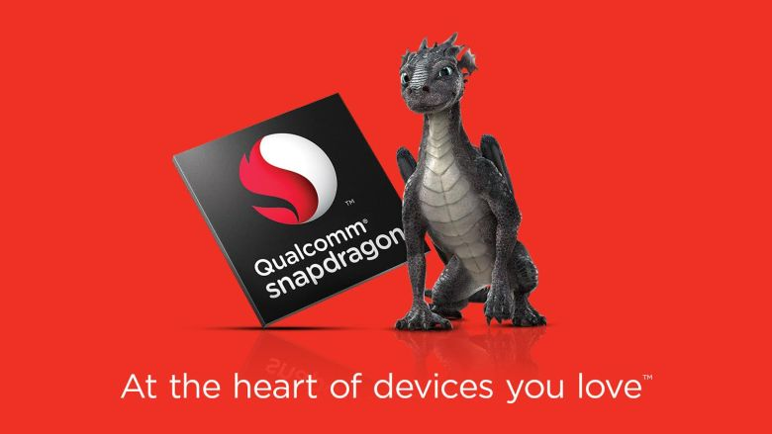
San Diego-headquartered Qualcomm got its start back in 1985 when electrical engineering professor-turned-entrepreneur Irwin Jacobs and six other industry veterans met at his home to discuss ways to create quality communications. The group founded Qualcomm Inc. that year and the start-up quickly began making history.
In 1988, Qualcomm launched a satellite-based data communications system for the transportation industry. In 1989, it demonstrated the world’s first wireless phone call, using CDMA (Code Division Multiple Access) technology. And in 1998, it introduced the first commercial CDMA smartphone.
Qualcomm, which went public in 1991and joined the S&P 500 index in 1999, has paved the way in mobile Internet connectivity, global-positioning satellite (GPS) and wireless broadband. The company’s $3.1 billion acquisition of chipmaker Atheros Communications, in 2011, enabled Qualcomm to move more aggressively into smartphones and tablets. Today, it makes the Snapdragon chip ubiquitous in mobile devices of all kinds.
Qualcomm was at the forefront of 3G and 4G cellular network technology and it’s now collaborating with industry leaders to lead the way with 5G. [For those wondering, “G” stands for generation.]
On the medical front, Qualcomm’s technology is helping patients who use home-based monitoring and diagnostic tools, such as inhalers, ventilators, blood pressure monitors and blood glucose meters. It’s also helping improve the efficiency and accuracy of patient data communications in hospitals.
More than 65% of Qualcomm’s employees are engineers. Team members have been called pioneers, dreamers, inventors, rebels and risk takers—labels the company says they embrace.
Over the years, Qualcomm’s many customers have included such companies as Alphabet, Apple, Comcast, Verizon and General Motors Co. At the moment, Qualcomm is involved in various antitrust lawsuits largely for having too much of a good thing – it charges companies every time they use its chips. It’s the uncertainty around these suits that have pressured its stock, allowing us to invest in the shares at a low price.

