Get to Know Your Stock: Winnebago Industries 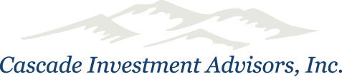

Winnebago Industries, a leading U.S. manufacturer of recreational vehicles, is cruising again. The company boasts no debt and recently reinstated its quarterly cash dividend following a sharp rise in net income and revenue.
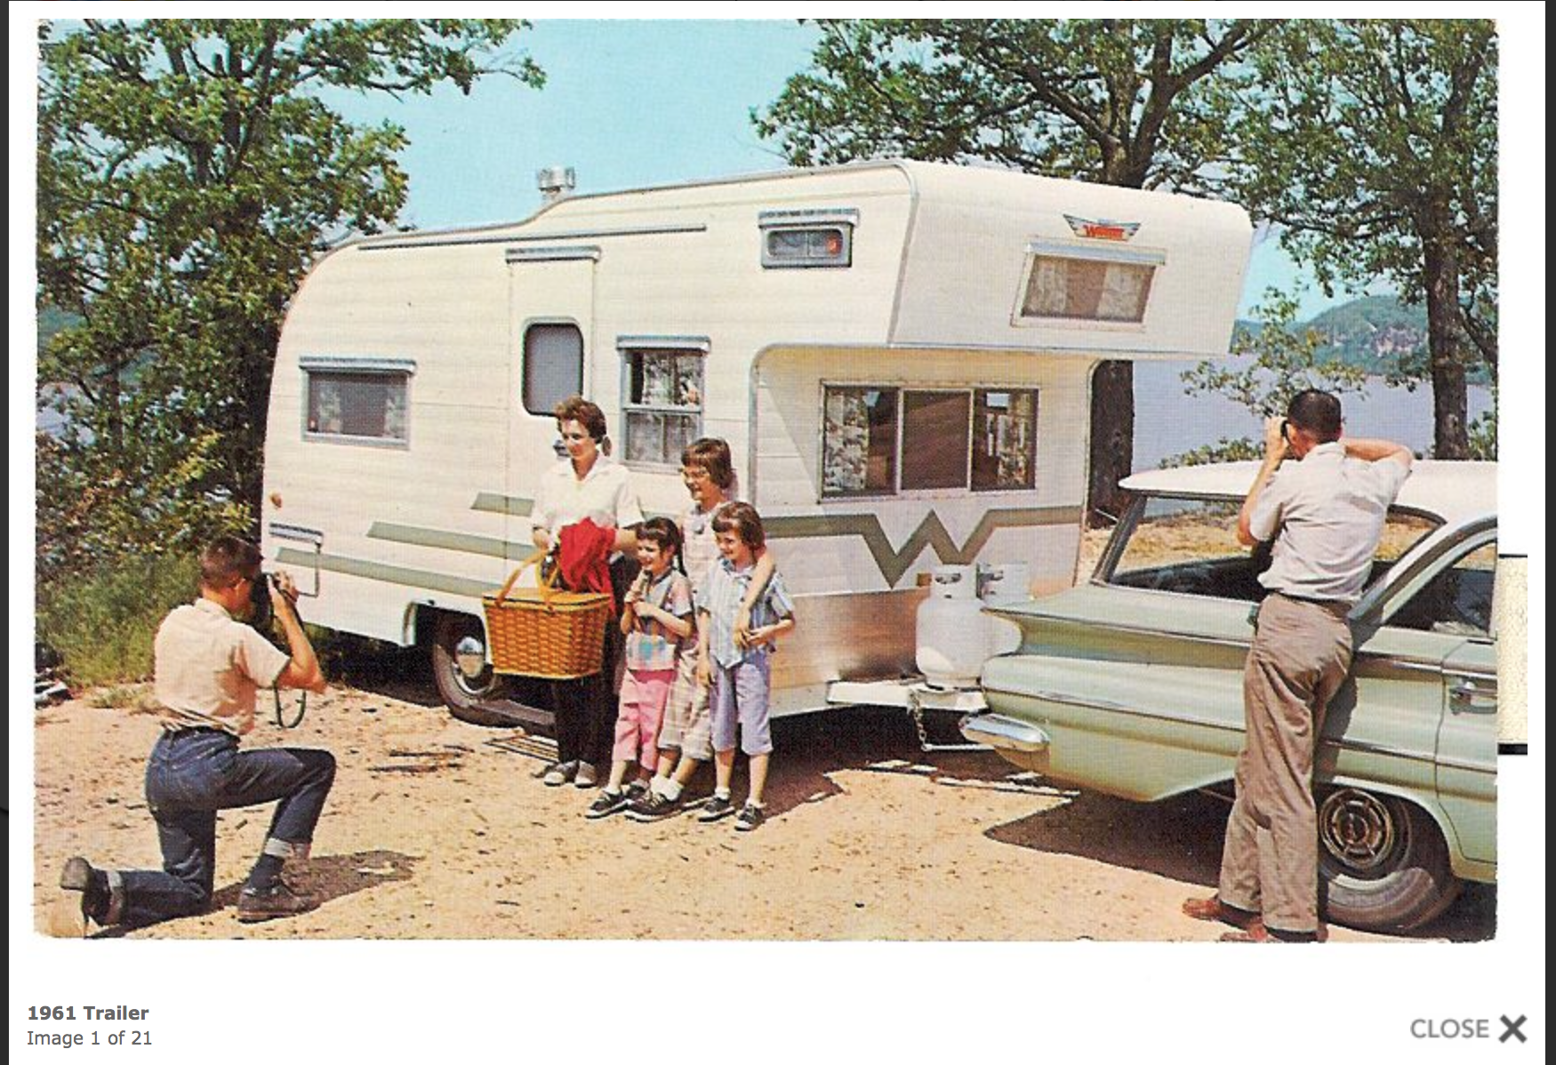
Forest City, Iowa-based Winnebago—whose early models were easily identified by their bold Flying W logo and iconic “eyebrow” design—got its start in 1958 when businessman John K. Hanson and a handful of other local residents convinced a California company to open a travel trailer factory in their economically depressed farming community. Despite a rough start, the determined Iowans purchased the operation the following year. Hanson (an avid camper and former mortician, according to his 1996 New York Times obituary) became president.
1961 Trailer

The company, situated in Winnebago County, adopted its present name in 1961. It spent several years developing innovative processes and parts before rolling its first motorhome off its assembly line in 1966. Winnebago went public in 1970. Its shares are listed on the New York and Chicago Stock Exchanges under the symbol “WGO.”

Winnebago broke an industry record in 1977 when it built its 100,000th unit. The company makes most of its parts and sells parts to other manufacturers. It also holds onto dies and molds should ancient replacement parts be needed. Recent submissions on the company’s Mywinnebagostory.com website tell stories of a handful of 40-something-year-old Winnies that are still on the road.

Winnebago’s premier motorhomes, Class A Diesel units, sport suggested base retail prices of approximately $126,000 to $426,000. Top-end luxury models in this category offer skylights with powered shades, slide-out rooms and other unique features. Its Class B, Class C and Class A Gas motorhome offerings are less expensive.

Several years ago, Winnebago returned to the towable segment of the RV market. We’re not talking about popup campers of 1960s and 1970s family vacations. These are comfortable units that include tankless hot water heaters, furniture-grade cabinetry, solid surface countertops, memory-foam mattresses and more.

Winnebago’s workforce is 2,850 people strong, many of whom have been onboard for years. It markets its RVs on a wholesale basis to dealers in the U.S. and Canada. As of August 2014, its dealer count topped 270 for motorhomes and 200 for towables. It recently entered the Australia-New Zealand market through a partnership with an Australia-based RV manufacturer.

Winnebago hopes to go the distance under favorable economic and demographic conditions. This includes what it refers to as the “silver tsunami” of retiring baby boomers—its target market. Nearly half of Winnebago owners are over 60 years old, but strong growth is emerging amongst 40-somethings as well.

Winnebago RVs have joined Hollywood’s elite in such films as Lost in America, Tin Cup, Terminator 3, About Schmidt, Talladega Nights, Batman Returns, Spaceballs and more. The outtakes reel from a 1988 sales ad made by a Winnebago salesman sparked the 2010 documentary Winnebago Man after going viral on YouTube.

Winnebago’s WIT Club, short for Winnebago International Travelers, is open to all its RV owners and has over 14,000 members. Last year, more than 1,300 Winnebago RVs and their owners attended the WIT Club Grand National Rally in Forest City. It’s hard to get more enthusiastic than that.

