Get To Know Your Stock: Nordstrom

Department store chain Nordstrom, Inc. (NYSE: JWN) has focused on providing shoppers with extensive inventory and superior customer service ever since Johan W. Nordstrom co-opened a small shoe store in downtown Seattle 115 years ago.
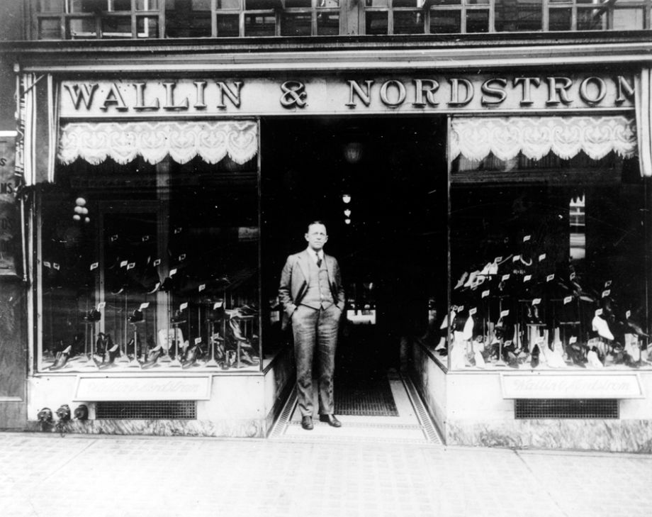
John (as he was later known) emigrated from Sweden in 1887 at age 16 and arrived in the U.S. with $5 and a sixth-grade education. According to the book The Nordstrom Way, he worked his way west while carting and loading iron ore onto railroad cars in Michigan, digging coal in Iowa, mining gold and silver in Colorado, logging trees in Washington state and California, and searching for gold in Alaska.

Upon settling in Seattle, John plunked down a portion of his gold-rush cash to establish the shoe store, Wallin & Nordstrom, in partnership with his Klondike pal Carl F. Wallin, a shoemaker. The store welcomed its first customers in 1901 with $3,500 worth of shoes that retailed from $1.95 to $4.95 a pair. John and Carl opened a second location in 1923. Both men retired later that decade and sold their shares of the company to John’s sons, but John went to the office until his early nineties.

Selling wasn’t a strong suit of the Nordstrom clan. “Dad’s probably the worst salesman in the business,” one of John’s sons reportedly told a Seattle newspaper, “and the only ones that could be worse are his three sons.” But they knew how to provide better selection, offer better value, and hire strong salespeople, he said. The customer was always right—and still is.

The Nordstrom brothers worried they’d have to permanently shutter the business during the Great Depression, but President Roosevelt’s New Deal programs helped resuscitate the Seattle economy just in the nick of time. During World War II, when inventory was scarce, the company worked hard to developed strong relationships with factories and traveling shoe salesmen.

In the 1950s, Nordstrom opened more shoe stores in the Pacific Northwest and leased shoe departments in department stores in eight states including Hawaii. By the early 1960s, Nordstrom’s flagship Seattle store was the nation’s largest independently owned shoe store. It also repaired shoes and once saved the day for Elvis Presley, whose boots split while he was in town filming a movie.

Nordstrom jumped into the women’s apparel business in the 1960s and went public in 1971. In addition to being fashion forward, the company is feet friendly. For decades, customers requiring shoes of different sizes have been able to purchase them for the price of a single pair. Today, fourth-generation Nordstrom’s runs the company with an outside executive team.

Nordstrom launched its first full-line stores in Canada in 2014, and its long-awaited New York City debut is slated for 2018. It operates 323 stores in 39 states and Canada, including nearly 200 Nordstrom Rack discount stores, and serves customers in 96 countries through Nordstrom.com. The company’s net sales hit a record $13.1 billion in 2014—larger than the GDP of some countries.

