Get to Know Your Stock: Gentex Corp.

Investors often fear that companies may be full of smoke and mirrors. But that’s the appeal of Gentex Corp. (NASDAQ: GNTX, headquartered in Michigan), which began as a manufacturer of smoke detectors before inventing and becoming the leading supplier of automatic-dimming rearview mirrors for the global automotive industry.
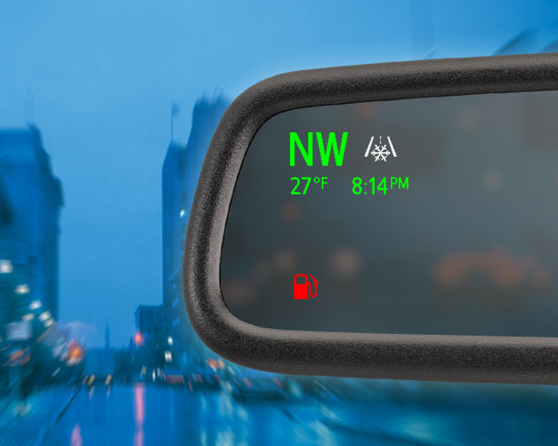
Gentex Chairman and CEO Fred Bauer, an electrical engineer, founded Gentex in 1974, largely because he was frustrated with fire control in his own commercial buildings. Gentex revolutionized the fire protection industry by creating smoke detectors that could actually see smoke particles. Millions of its fire protection products, including alarms and carbon monoxide detectors, are used worldwide in schools, hospitals, hotels, office buildings, and other commercial and residential locations.

But 98% of Gentex’s net sales are to customers in the automotive industry. Back in 1982, the company introduced the world’s first auto-dimming rearview mirrors, which use sensors and electronic circuitry to reduce glare at night. Today, Gentex holds more than 90 percent of the global market share for these mirrors.

Gentex supplies every major automaker with features that can help improve driver vision and safety. A decade ago, it became the first company to start integrating video displays into vehicle mirrors. Its electro-optical advancements include rear camera displays and blind spot alerts. It has 1,220 patents and 204 registered trademarks—and more on the way.

In January 2017, Gentex introduced two more innovative systems. Its new biometric mirror system does an iris scan to authenticate a driver who enters a vehicle. After authenticating, the system will start the vehicle, adjust the mirror and seats for the driver and set the driver’s music preferences. Gentex’s new three-camera rear vision system combines the rear and side views, tripling the driver’s field of view.

Gentex is also partnering with a company to integrate toll-paying capabilities into rearview mirrors, eliminating the need for physical transponders.

Several years ago, Gentex acquired HomeLink, a leading wireless home/vehicle communications product that enables drivers to open garage doors and gates, activate and deactivate home security systems, and control their home lighting, appliances and electronics—all from inside their cars.

If you’ve traveled on a Boeing 787 Dreamliner, those automatically dimming windows you saw are another Gentex technology. The windows dim when electrical currents heat up a gel between the layers of glass. Goodbye mini plastic shades.

Gentex has more than 4,700 full-time employees worldwide. How many Gentex engineers does it take to change a light bulb? Not sure, but the company certainly wants to help people see more clearly and be safer.

