***Celebrity Stocks of the Late 90’s: Where are They Now?***

In the quest for news on our stocks, we are frequently accosted by “Sponsored” content sporting titles like “You should see Cheryl Ladd now!” or “Unbelievable photos of former child stars!” In this vein, we decided to check back with some of the stock market stars of the late 1990’s tech boom. The purpose of this historical dig is to remind investors that ‘the more things change, the more they remain the same” ie, favorites often do not last. At the end of this piece we relate history to today’s “stars”. We’re not making forecasts, but history does tend to rhyme.

In the late 1990’s, tech stocks were all the rage. Viewing charts, many looked like this:

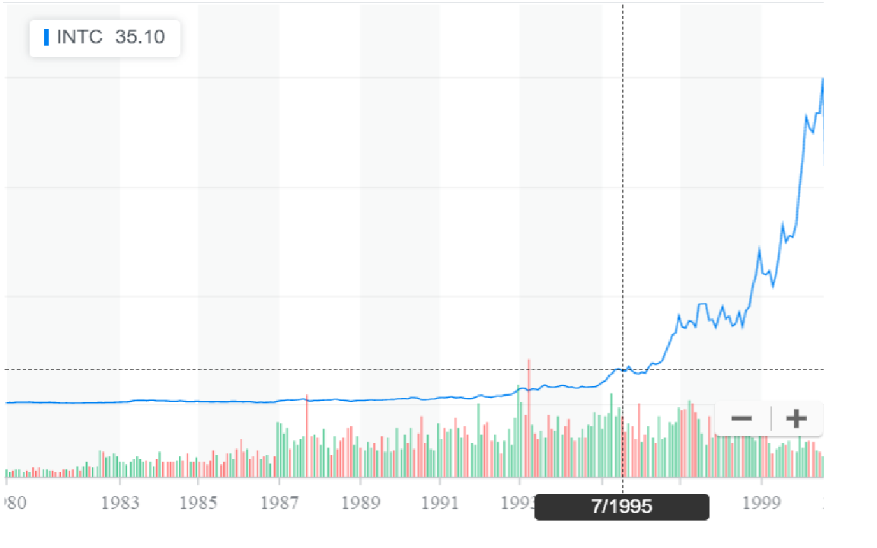

This one is Intel but they all look the same. What happened later, of course, is that Intel crashed and has never regained its high. We sifted through the many skyrocketing stocks back then, and came up with this list of mostly ill-fated issues from among the top ten performers of the time (a couple others were acquired):



Choosing the best of this lot, Amazon, still would have entailed a five year wait before the stock recovered, just in time for the ’08-’09 recession when the stock once again fell dramatically, to about $35. And although the odds of success were truly horrible if an investor bought this entire list, plenty of other stocks acted similarly so it would have been easy to come up with disappointing performance in the ‘tech wreck’.

Today, many stock charts look like Intel did. But many do not, including retail, energy and REIT companies. Back in 2000, health care companies were very strong after an uneven 1999; and energy stocks lagged badly going into the late 90’s, then rebounded strongly as the new decade opened. They were the market’s saviors. At some point, investors will be in for a switch, when the leaders begin to lag, and the losers begin to lead. Hopefully it won’t take the kind of bloodbath of 2000-2002 to trigger this switch.