Cascade Investment Advisors

CHARITABLE LENDING

NEWSLETTER

October 2017

THIS OCTOBER, WE’RE HIGHLIGHTING OUR CHARITABLE LENDING EFFORTS ON A CLOTHING GROUP IN NICARAGUA

Sendas de Paz Group in Nicaragua
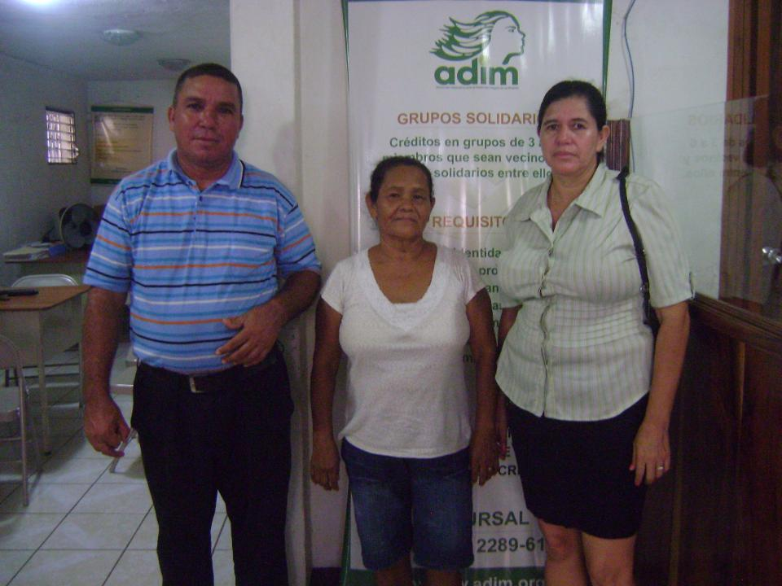
The Sendas de Paz group is made up of three hard-working people, coordinated by Ana. She is 45 years old and has made a living selling clothing for seven years. This is her fourth loan cycle with the Kiva lender and she is requesting a loan of $1,100 USD to invest in purchasing more clothing and sandals to expand her business. The other members: María and Eduardo, both are 44 years and also sell clothes.
About Sendas de Paz Group in Central America...
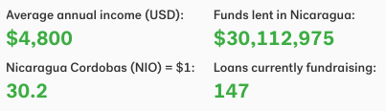
One of the poorest countries in the Western Hemisphere, the country of Nicaragua sits just between Honduras to the North and Costa Rica to its South. The country is still struggling to overcome the effects of dictatorship and civil war that left its economy and people reeling. Join us lending to entrepreneurs like Sendas de Paz Group to help them help themselves and their families. Join our Kiva group “The Microlending Fund” at Kiva.org.

